A.V Bhargava(191911110)

**7.Railway Reservation System**

**1.Class Diagram**

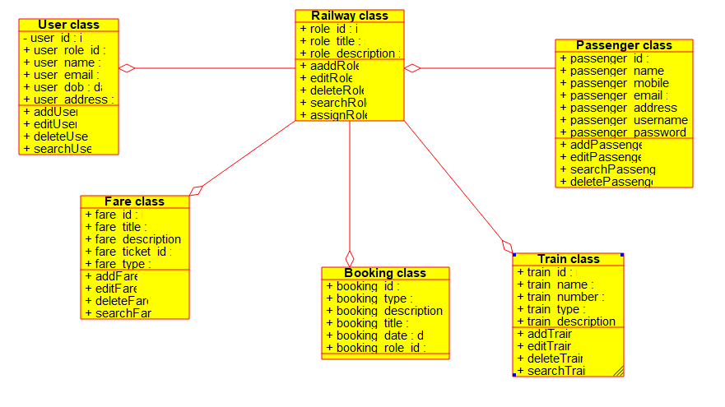

**2.Usecase Diagram**

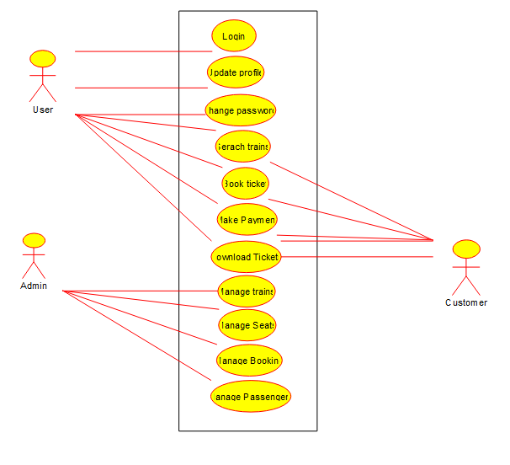

**3.Sequence Diagram**

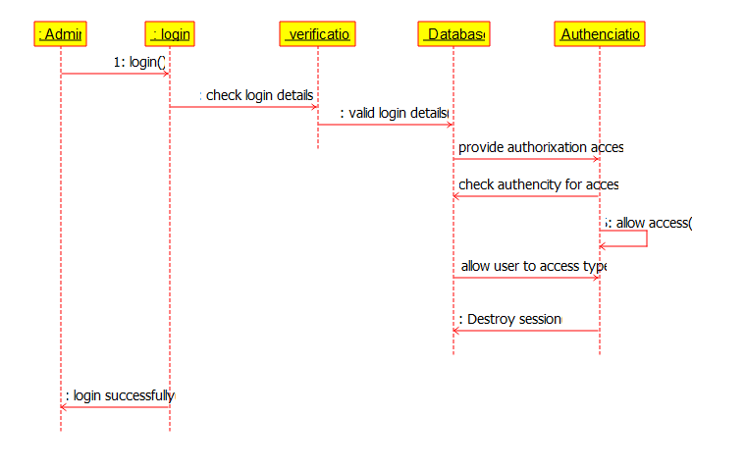

**4.State Diagram**

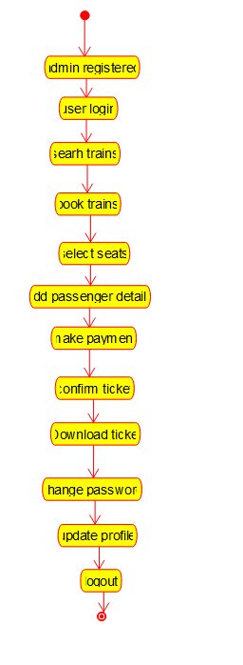

**5.Activity Diagram**

